C++ Code Testing Procedure

Prepared by: Jared Oliphant on 4/11/19

The Autograding system uses the G++ GNU C++ Compiler on the CAEDM Linux machines to compile and run your C++ lab submissions. Using this compiler to test will allow you to be certain that there will not be any unforeseen compiler issues when you submit your lab to be graded.

Here are instructions to compile and run your code remotely with a CAEDM Windows machine.

1. Save your .cpp file somewhere on your J Drive that is easily accessible (i.e. J:\Documents\)
2. Search Windows for ***PuTTY via Citrix***
3. Opening this application you should see this window:

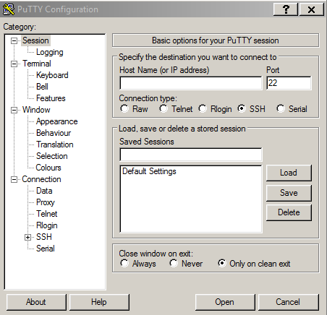

1. In the field Host Name (or IP address)type the following:

***caedm_username@ssh.et.byu.edu*** replacing caedm_username with your actual CAEDM username

1. Press Open
2. The first time you connect you will receive a warning dialog that shows this:

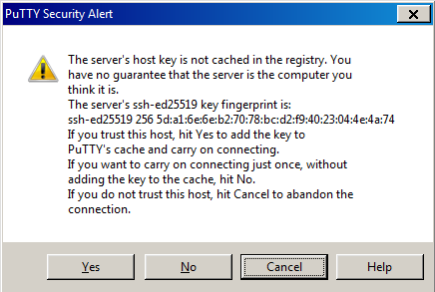

1. Click Yes
2. You will then be prompted for your password like this:

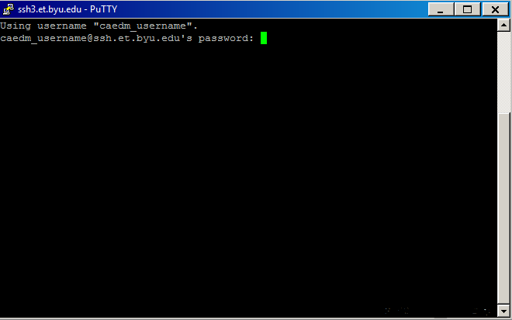

1. Navigate to the location of your .cpp file (i.e. ***cd Documents***)

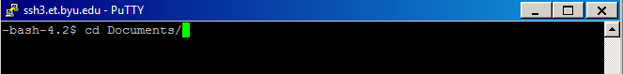

1. Print contents of current directory with ***ls***

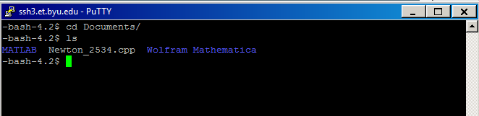

1. Use the following command to compile your .cpp into an .exe (executable):

***g++ Newton_2534.cpp –o Newton_2534.exe -std=c++11*** replacing the name of the file for your file

1. If the compile works with no errors, then printing the contents of the directory again should now show the .exe you just created.

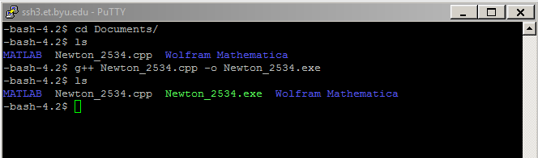

1. To run your executable, type:

***./Newton_2534.exe***

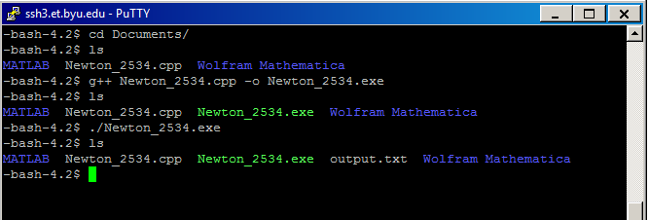

1. As long as any input files are in the same directory, the code should run and produce any desired output files. Notice the “output.txt” file that was created above.
2. You can view the contents of your output file with ***cat output.txt*** command:

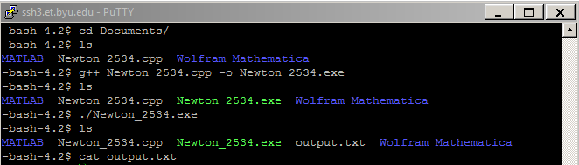

1. If the contents are as expected and the compiling and running produced no errors, you can be confident the Autograding system will also work well. Be sure to test your code with many different inputs to ensure robustness.

Further helpful links:

YouTube video demo

<https://youtu.be/aofhxoQfsxg>

Basic Linux terminal commands

<https://www.pcsuggest.com/basic-linux-commands/>

<https://learn.adafruit.com/an-illustrated-shell-command-primer/introduction-adventuring-in-the-shell>

SSH on the CAEDM Wiki

<https://caedm.et.byu.edu/wiki/index.php/SSH>